Exercise 1: Ranking and Window Functions
CREATE TABLE Employee ( EmpID INT PRIMARY KEY, EmpName VARCHAR(50), Department VARCHAR(30), Salary INT );
INSERT INTO Employee VALUES
(101, 'Alice', 'HR', 50000),
(102, 'Bob', 'IT', 70000),
(103, 'Charlie', 'IT', 70000),
(104, 'David', 'HR', 60000),
(105, 'Eva', 'Sales', 45000),
(106, 'Frank', 'Sales', 55000);
--Row number
SELECT EmpID, EmpName, Department, Salary, ROW_NUMBER() OVER (ORDER BY Salary DESC) AS Row_Number FROM Employee;
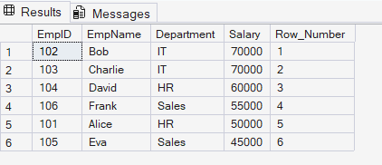
--Rank()
SELECT EmpID, EmpName, Department, Salary, RANK() OVER (ORDER BY Salary DESC) AS Rank_Value FROM Employee;
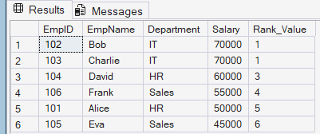
--Dense Rank
SELECT EmpID, EmpName, Department, Salary, DENSE_RANK() OVER (ORDER BY Salary DESC) AS Dense_Rank FROM Employee;
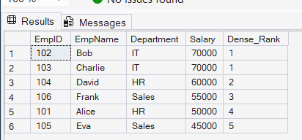
--ROW_NUMBER() with PARTITION BY
SELECT EmpID, EmpName, Department, Salary, ROW_NUMBER() OVER (PARTITION BY Department ORDER BY Salary DESC) AS Dept_Row_Number FROM Employee;
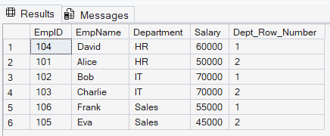
--Top 3 Employees in Each Department using DENSE_RANK()
WITH EmployeeRanks AS
(
SELECT
EmpID,
EmpName,
Department,
Salary,
DENSE_RANK() OVER
(
PARTITION BY Department
ORDER BY Salary DESC
) AS DenseRankValue
FROM Employee
)
SELECT *
FROM EmployeeRanks
WHERE DenseRankValue <= 3;
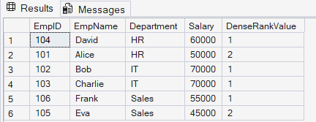
--Top 3 Employees in Each Department using RANK()
WITH EmployeeRanks AS (
SELECT
EmpID,
EmpName,
Department,
Salary,
RANK() OVER
( PARTITION BY Department
ORDER BY Salary DESC
) AS RankValue
FROM Employee )
SELECT * FROM EmployeeRanks WHERE RankValue <= 3;
